The Club has regular gatherings at various Caravan Parks throughout New South Wales and extended trips away. Our members receive Newsletters with updates of special events and items of interest during the year.
The Club has a Website with many photos of past events, technical tips, modifications to vans, useful information and club itinerary.
http://www.sccavanners.com
Membership is open to individuals who own an A’van Camper, Caravan or Recreation Vehicle Manufactured by A’van Campers & Caravans including the Golf and Knaus brands.
If you are considering joining you are encouraged to attend one “Gathering” before applying for membership.
If you wish to apply for membership please complete the “Application for Membership” Form on the website.

Sydney – Central Coast A Van Group Inc. is a member of the NSW Association of Caravan Clubs Inc.
The Sydney-Central Coast A Van Group Inc. is a non-profit organisation formed:
- To share ideas of common interest and mutual benefit;
- To encourage and foster friendship and co-operation amongst people who are owners of any product manufactured by A’van Campers and Caravans
- To hold meetings, lectures, demonstrations, outings, and competitions for the furtherance of member’s interests;
- To encourage all members whilst participating in Group activities to act in an environmentally and socially responsible manner and in accordance with the law;
- To provide, from funds, a Newsletter on a regular basis.
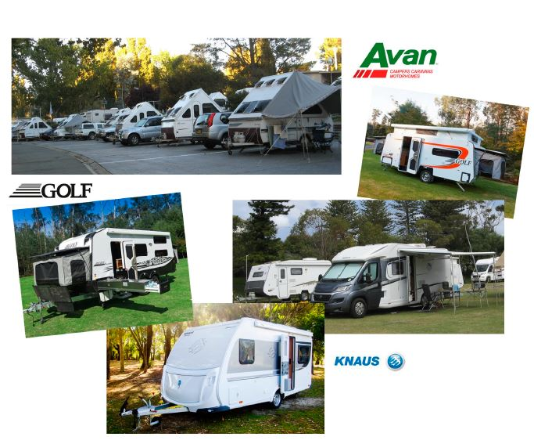
Membership Fees collected are used to support the management and expenses incurred by the organisation.
For further information please contact The Secretary:
Email: sccavan@gmail.com
Website: http://www.sccavanners.com

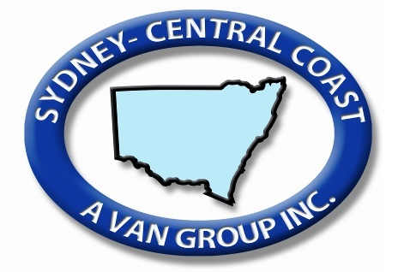
ABN: 62 842 468 219
The Club for owners of all vans manufactured by A’Van Campers & Caravans

